|  |
| --- |
| InterNAL COMBUSTION ENGINES ii |
| Units and Equation Solving |
| Assignment 01 |
| **Arjun Darbha** |
| **9/13/2013** |



**A. Introduction**

The objective of this assignment is to lay hands on software tools, especially MATLAB and EES, programs which are typically used for plotting and solving equations simultaneously. In Part C experimental data is provided and correlation analysis is performed in order to arrive at the best model for explaining experimental results. Part D deals with First law analysis of a control volume inside the engine cylinder and estimation of kernel temperature by using basic constitutive relations of thermodynamics. This work helps in reviewing the fundamentals on basic thermodynamics, internal combustion engine and unit conversion/plotting/data analysis.

**B. Data Visualization plotting and fitting**

When high voltage is induced across the coils, at a certain voltage called the breakdown voltage VBD, electrical conductivity of air between the electrodes increases enormously ionizing air between the electrodes. This induces a spark which is responsible for a spark in during a compression stroke in a SI(Spark Ignition) IC Engine. The data presented as a part of the problem statement is deduced from the experimental results. For better comprehension, gap between the electrodes is plotted against breakdown voltage in fig.1. The experimental data clearly shows that the value of breakdown voltage increases with increase in breakdown voltage, which means that there exists a proportional relation between electrode gap and breakdown voltage. Fig.1 also denotes other well known correlation models.

Thumb rule states that (Equation 1)

$V_{BD}=3*d_{g}$**Equation 1**

Though Eq.1 captures increasing trend of data, it does not capture the points at the lower and upper end of the experimental data as well as other models do. Also from Table1, it can be seen that a simple root mean square (RMS) calculation of results shows that the basic thumb rule is not a better correlation when compared to other correlations. Eq.2 describes Paschen’s law with additional variables namely pressure and temperature

$V_{BD}=24.22*f+6.08*\sqrt{f}$**Equation 2**

$f=\frac{\left(293*p*d_{g}\right)}{760*T}$ Equation 3

where

p = pressure[Torr]

T = temperature[K]

dg = gap length [cm]

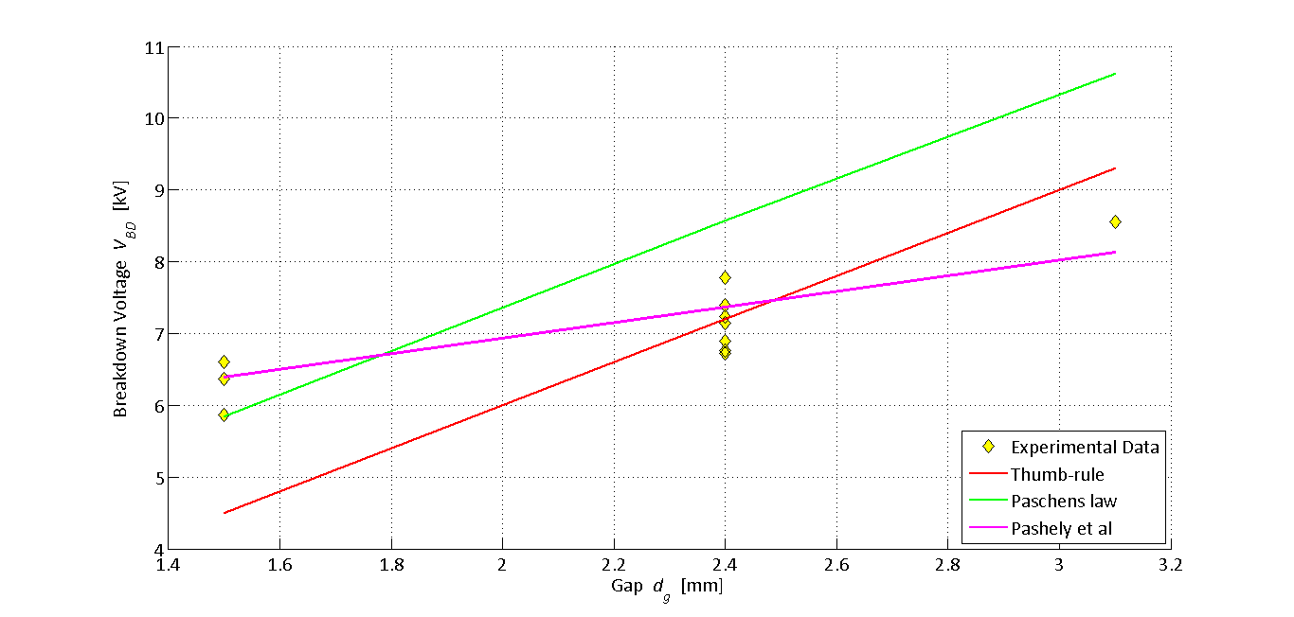

Figure 1 Experimental data compared with different theoretical correlations

Paschen’s law also captures increasing trend in the data but does not pass through all the data points. Also, RMS error is higher than the previous case when Paschen’s law is used. Hence Pashen’s law is not a good alternative.

Correlation model provided by Pashley et al looks like a good model as it seems to capture the entire data. Also, it has the least RMS error when compared to other models provided. Also, this is the reason why this model is used for energy calculation inside the kernel in the next section of the assignment

When different models are compared from the mathematical standpoint, it can be clearly seen that a quadratic relation is the closest fit in terms of minimum RMS error. MATLAB code is used to determine the algebraic equation of a line with best fit. The code used is attached in APPENDIX A.

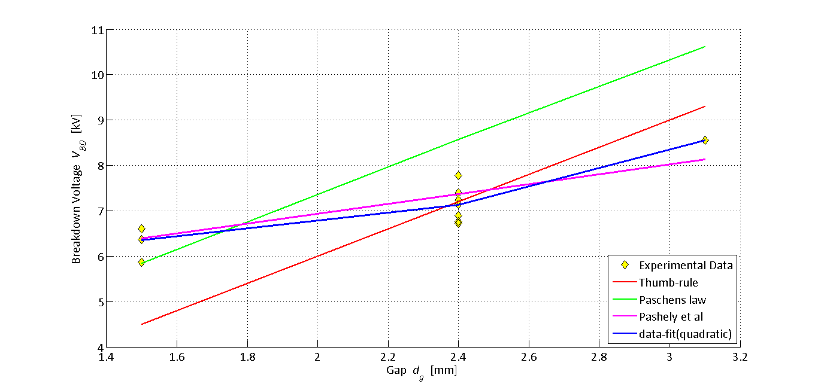

Figure 2 Experimental data with a quadratic curve-fit

From MATLAB, the quadratic equation can be formulated as

$V_{BD}=0.7318d_{g}^{2}- 1.9881d_{g}+ 7.6906$**Equation A**

**Table 1. Error estimation in different correlations**

|  |  |
| --- | --- |
| **Model** | **RMS error** |
| Thumb rule | 1.1392 |
| Pashen’s law | 1.3237 |
| Pashely et al | 0.3870 |
| First order correlation | 0.3708 |
| Second order correlation | 0.3202 |
| Third order correlation | 0.3263 |
| Fourth order correlation | 0.3894 |

**C. Basic Engine Analysis**

The results of the analysis above are used in this section to explain ignition conditions in a Ford EcoBoost engine. Table 2 describes the important parameters of the engine in both English and SI units. The formula used for calculating BMEP is

$bmep=\frac{6.28n_{R}T}{V_{d}}$ Equation 4[1]

where

* T = Torque in Nm
* nR = 2 for a four stroke engine
* Vd = Volume displaced in L

Table 2. Ford 2011 EcoBoost Engine Characteristics

|  |  |  |
| --- | --- | --- |
| **Parameter** | **Value** | **SI Unit** |
| Cylinders(#) | 6 | - |
| Bore (mm) | 92.5 | 0.0925m |
| Stroke (mm) | 86.7 | 0.0867m |
| Connecting Rod Length (mm) | 152.7 | 0.1527m |
| Compression Ratio (#) | 10:1 | - |
| Displacement (L) | 3.5 | 0.0035m3 |
| Maximum Torque @ 2500rpm (lbf-ft) | 420 | 569.4Nm |
| Maximum Horsepower @ 5500 rpm (hp) | 365 | 272.2kW |
| Maximum boost (psig) | 14.5 | 99.97kPa |
| Max BMEP (bar) | 21.87 | 2187kPa |

Table 3 is used to determine PIgn and TIgn, ignition breakdown voltage and ignition energy from the given parameters. The state of the working fluid, air in this case, is determined right before the ignition event occurs. For this, basic equations of state are used. Since the Engine MAP values and engine parameters are known, the Pressure (Pi) and Volume (Vi) of air at BDC are known. Here, it has to be realized that the engine parameter known from Table 2 is Volume displaced (Vd) – which is not equal to the volume of the cylinder at BDC. However since the value of compression ratio is known, this value can be easily deduced from equation 5

$Compression ratio=\frac{Total Volume of the cylinder}{Clearance Volume}$ Equation 5

Table 3 reveals that degrees BTDC is known for an ignition event. Hence, volume of the cylinder at this point can be calculated using the equation

$\frac{V}{V_{c}}= 1+\frac{1}{2}*\left(r_{c}-1\right)[R+1-cosθ-(R^{2}-\sin^{2}{θ)^(0.5)] }$ Equation 6

where

* V = Total volume of the cylinder
* Vc = Clearance volume
* rc = Compression ratio
* R = Ratio of connecting rod to crank radius (crank radius is half of stroke)
* Theta = degrees BTDC

The following assumptions are made for calculating the temperature and pressure before ignition.

* It is assumed that working fluid is air, as an ideal gas
* As the gas is compressed inside the cylinder, it is assumed that it occurs polytropically, with n=1.32
* The temperature at which air enters the cylinder is not mentioned explicitly, but an informed assumption can be made as follows
  + In the first case where MAP value is 40kPaa - less than atmospheric pressure, it can be assumed that engine is not boosted and the air undergoes expansion across the throttle valve. As air is assumed to be an ideal gas throttling should not have an effect on its temperature. Hence, the temperature for this case can be assumed to be 298K
  + In the second case where MAP value is 200kPaa, it is assumed that the engine is boosted and hence the temperature of the air has to increase. However an intercooler reduces the temperature of air before it enters the cylinder. Hence, an informed assumption of 300K is made in this case[2]

The equations used for calculating Pign and Tign are

$P_{ign}V_{BTDC}^{n}=P_{initial}V_{initial}^{n}$ Equation 7

$P_{ign}^{1-n}T_{ign}^{n}={ P}_{initial}^{1-n}T_{initial}^{n}$ Equation 8

In Equation 7, Pinitial, Vinitial, VBTDC and n are known values and hence Pign can be calculated. In Equation 8, Pign, Pinitial and Tinitial are known values, hence, TIgn  can be calculated.

Table 3. Operational range of the engine for ignition parameters

|  |  |  |  |  |  |  |  |
| --- | --- | --- | --- | --- | --- | --- | --- |
| **Engine Speed** | **Engine  MAP** | **Ignition  Timing** | **PIgn** | **TIgn** | **Ignition Gap** | **Ignition VBD** | **Ignition  BD and Arc Energy** |
| (rpm) | (kPaa) | (°BTDC) | (bar) | (K) | (mm) | (kV) | (mJ) |
| 700 | 40 | 50 | 1.96 | 438.3 | 0.6 | 5.78 | 334.2 |
| 700 | 40 | 50 | 1.96 | 438.3 | 1.4 | 6.94 | 482.0 |
| 2500 | 200 | 25 | 23.63 | 542.3 | 0.6 | 18.70 | 3496.0 |
| 2500 | 200 | 15 | 32.88 | 587.4 | 1.4 | 37.30 | 13910.0 |

Several important deductions can be made from the table. The following are worth mentioning

* Ignition pressure increases with decrease in degrees before BTDC. This can be attributed to the fact that the volume of the cylinder decreases as the BTDC goes down
* As the pressure increases, the temperature increases. This fact is reflected by TIgn  column in Table 2
* VBD values are calculated from Pashley et al’s correlation which is dependent on Pressure and Temperature values and electrode gaps for calculating Voltage Breakdown. Since there exists a different combination of the values mentioned above, VBD for each case is different
* Figure 3 compares the values calculated-using basic laws, with the results published by Bosch. By comparing the distance of data points for 0.6mm and 1.4mm gaps from the straight line, it can be deduced that for a no 40kPaa no boost condition, 0.6mm gap seems to be closer to the result. However, for 200kPaa boosted condition, 1.4mm gap seems to be closer. Distortion in these values can be expected because the experimental conditions at which these tests are performed by Bosch are not explicitly mentioned with the test data. Also, the number of data points are too less to deduce a valid functional relationship between ignition breakdown voltage and electrode gap.

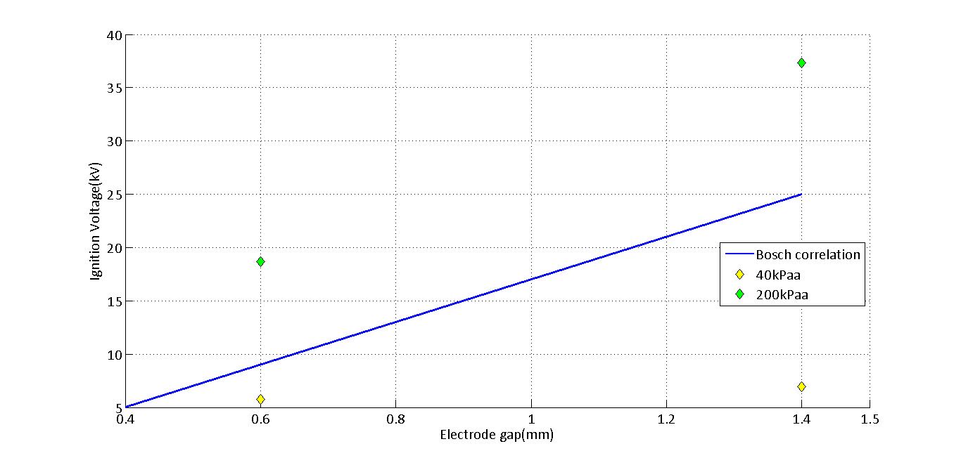**Figure 3 Comparison of calculated ignition breakdown voltages with Bosch’s results**

**D. First law analysis**

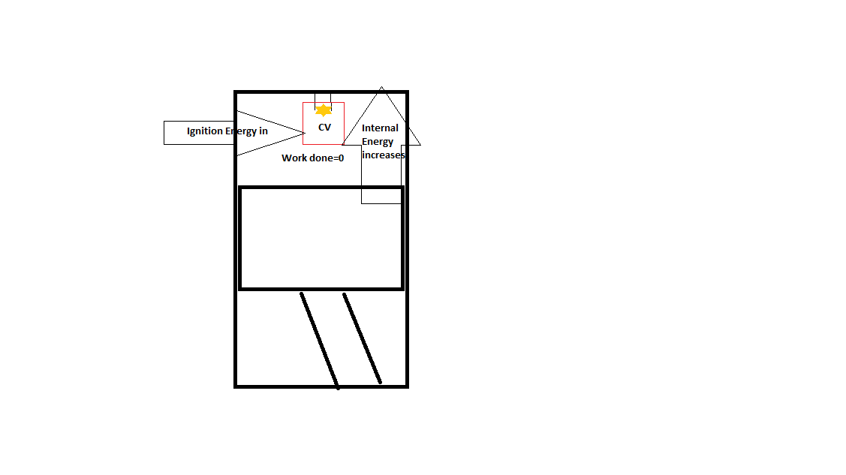

Figure 4 Energy transfer in control volume that encompasses the kernel

This part of the report aims to estimate the temperature of kernel by applying first law to the kernel. Control volume is denoted by a box in the figure 4. However, the analysis is based on the fact that CV is a sphere of radius 1.5 times that of gap between the electrodes. Hence the box is just a visual representation of a spherical CV. The first law analysis is also based on the fact that control volume is fixed and the expansion of gases within the control volume is negligible. Hence work done can be neglected. By applying first law to the control volume,

$∆E=∆U+∆W$ Equation 9

$∆E_{ignition}= ∆U+0$ Equation 10

$∆E_{ignition}= mC_{v}\left(T_{kernel}-T_{ignition}\right)$ Equation 11

In Equation 11, Eignition, Cv and Tignition are known values. m and Tkernel are not known. To solve this equation, following constitutive equations can be used

$P_{ignition}=ρRT_{ignition}$ Equation 12

$ρ=\frac{m}{V_{BTDC}}$ Equation 13

From Equations 11, 12 and 13 Table 4 can be deduced

Table 4 Table of knowns and unknowns

|  |  |
| --- | --- |
| **Knowns** | **Unknowns** |
| Eignition, Cv, Tignition, VBTDC | m, density(rho),Tkernel |

From equations 11, 12 and 13 and Table 4, we can conclude we have three unknowns to solve for, with three equations. The equations are solved in EES and are attached in Appendix B

The temperature estimated by solving equations in EES is **824.2[K].** This temperature is less when compared to the temperatures mentioned in figure 9-42 in Heywood. This is because, the analysis does not consider fuels or any thermo-chemistry involved in the process of combustion. This adds significant amount of heat to the working fluid and hence the temperature surges to such high values

**E. Summary and conclusion**

Several important conclusions can be made from this work

* Plotting in MATLAB enables multiple plot generation with remarkable accuracy and also provides options to make plots visually appealing
* EES can be used to solve simultaneous equations and also accurate unit conversions
* Correlations provided do not accurately denote the experimental results under all conditions. Hence, a functional relationship was developed between breakdown voltage and ignition energy
* Basic laws of thermodynamics can be used to estimate the states of working fluids in the cylinder. Though the values estimated are not accurate, it is important to realize that the physics remains the same; hence it can be used to cross validate the experimental results
* The temperature of the kernel obtained using first law of thermodynamics is not close to the actual engine temperature. This can be expected because it is the combustion of fuel that contributes to a major part of heat added to the gases in the combustion chamber of an IC Engine
* Nevertheless, thermodynamics does provide an estimate of the temperatures and pressures, when informed assumptions about the operating conditions of an IC Engine are made

**APPENDIX A**

*MATLAB CODE USED FOR PLOTTING*

**A.1 Code used for generating Fig.1**

clear all

clc

P_torr = 750;

P_bar = 1;

T_K = 298;

DG = [1.5 1.5 2.4 3.1 2.4 2.4 2.4 2.4 2.4 2.4 1.5 1.5];

VBD = [5.86 6.6 7.4 8.56 7.24 6.76 6.72 7.14 7.78 6.9 6.6 6.36];

figure

hold on

h_1 = plot(DG,VBD,'kd');

set(h_1,'markersize',9,'markerfacecolor','y');

VBD_corr1 = 3*DG; %Thumb-rule

h_2 = plot(DG,VBD_corr1,'r');

set(h_2,'linewidth',2,'markersize',9,'markerfacecolor',[1 0 0]);

f = ((293*P_torr)/(760*T_K)).*DG/10;

VBD_corr2 = 24.22*(f) + 6.08*sqrt(f); %Pashen’s law

h_3 = plot(DG,VBD_corr2,'g');

set(h_3,'linewidth',2,'markerfacecolor',[0 1 0]);

VBD_corr3 = 4.3 + 136*(P_bar/T_K)+324*(P_bar/T_K).*DG; %Pashley

h_4 = plot(DG,VBD_corr3,'-m');

set(h_4,'linewidth',2)

p = polyfit(DG,VBD,2);

fit = polyval(p,DG);

h_5 = plot(DG,fit); %Curve-fit

set(h_5,'linewidth',2)

grid on;

set(gca, 'fontname', 'Calibri', 'fontsize', 16);

xlabel('Gap {\it d_g } [mm]');

ylabel('Breakdown Voltage {\it V_{BD} } [kV]');

legend('Experimental Data','Thumb-rule','Paschens law','Pashely et al','data-fit(quadratic)', 4);

%Check for the fit

corr1_error = rms_error(VBD,VBD_corr1)

corr2_error = rms_error(VBD,VBD_corr2)

corr3_error = rms_error(VBD,VBD_corr3)

corr4_error = rms_error(VBD,fit)

**A.2 Code used for generating Fig.2**

figure

hold on

X = [0.4 1.4];

Y = [5 25];

p2 = plot(X,Y);

set(p2,'linewidth',2);

set(gca,'fontname','Calibri','fontsize',16,'XLim',[0.4 1.5],'XTick',[0.4 0.6 0.8 1.0 1.2 1.4 1.5]);

X_1 = [0.6 1.4];

Y_1 = [5.78 6.94];

X_2 = [0.6 1.4];

Y_2 = [18.70 37.3];

p3 = plot(X_1,Y_1,'kd');

p4 = plot(X_2,Y_2,'kd');

set(p3,'markersize',9,'markerfacecolor','y');

set(p4,'markersize',9,'markerfacecolor','g');

xlabel('Electrode gap(mm)');

ylabel('Ignition Voltage(kV)')

legend('Bosch correlation','40kPaa','200kPaa');

grid on

**APPENDIX B**

*EES CODE USED FOR UNIT CONVERSION AND SOLVING EQUATIONS*

**B.1 Unit conversion**

Bore = 92.5 [mm]*convert(mm,m) "Convert mm to m"

Stroke = 86.7 [mm]*convert(mm,m)

connectRod = 152.7 [mm]*convert(mm,m)

Displacement = 3.5 [L]*convert(L,m^3) "Convert L to m^3"

Tmax = 420 [lbf-ft]*convert(lbf-ft,N-m) "Convert lbf-ft to N-m"

Pmax = 365 [hp]*convert(hp,kW) "Conver hp to kW"

maxBoost = 14.5 [psig]*convert(psig,kPa) "Convert psig to kPa"

**B.2 Estimation of Ignition parameters**

Vd = 3.5[L] {Displaced volume}

Rc = 10 {Compression ratio}

Rc = (Vd+Vc)/Vc

Vcyl = Vd+Vc {Total Volume of cylinder}

Tamb = 298[K] {Ambient temperature}

C = 20*(1e-12) {Secondary capacitance}

P1 = 40 {Initial Pressures}

P2 = 40

P3 = 200

P4 = 200

THETA1 = 50 {BTDC}

THETA2 = 50

THETA3 = 25

THETA4 = 15

R = 152.7/43.35 {Crank length/radius}

n = 1.32 {polytrpic index}

V1/Vc = 1 + 0.5*(Rc-1)*(R+1-cos(THETA1)-(R^2-sin(THETA1)^2)^0.5)

V2/Vc = 1 + 0.5*(Rc-1)*(R+1-cos(THETA2)-(R^2-sin(THETA2)^2)^0.5)

V3/Vc = 1 + 0.5*(Rc-1)*(R+1-cos(THETA3)-(R^2-sin(THETA3)^2)^0.5)

V4/Vc = 1 + 0.5*(Rc-1)*(R+1-cos(THETA4)-(R^2-sin(THETA4)^2)^0.5)

(P1Ign)*(V1^n) = P1*(Vcyl^n) {Ignition pressures}

(P2Ign)*(V2^n) = P2*(Vcyl^n)

(P3Ign)*(V3^n) = P3*(Vcyl^n)

(P4Ign)*(V4^n) = P4*(Vcyl^n)

(P1Ign^(1-n))*(T1Ign^n) = (P1^(1-n))*(Tamb^n) {Ignition temperatures}

(P2Ign^(1-n))*(T2Ign^n) = (P2^(1-n))*(Tamb^n)

(P3Ign^(1-n))*(T3Ign^n) = (P3^(1-n))*(Tamb^n)

(P4Ign^(1-n))*(T4Ign^n) = (P4^(1-n))*(Tamb^n)

P1Ignbar = P1Ign*convert(kPa,bar) {Ignition pressures in bar}

P2Ignbar = P2Ign*convert(kPa,bar)

P3Ignbar = P3Ign*convert(kPa,bar)

P4Ignbar = P4Ign*convert(kPa,bar)

{Breakdown Voltage}

VBD06A = 4.3 + 136*(P1Ign*convert(kPa,bar)/T1Ign) + 324*(P1Ign*(convert(kPa,bar))/T1Ign)*0.6

VBD14A = 4.3 + 136*(P2Ign*convert(kPa,bar)/T2Ign) + 324*(P2Ign*(convert(kPa,bar))/T2Ign)*1.4

VBD06B = 4.3 + 136*(P3Ign*convert(kPa,bar)/T3Ign) + 324*(P3Ign*(convert(kPa,bar))/T3Ign)*0.6

VBD14B = 4.3 + 136*(P4Ign*convert(kPa,bar)/T4Ign) + 324*(P4Ign*(convert(kPa,bar))/T4Ign)*1.4

EBD06A = 0.5*(C)*((VBD06A*1000)^2) {Ignition Energy}

EBD14A = 0.5*(C)*((VBD14A*1000)^2)

EBD06B = 0.5*(C)*((VBD06B*1000)^2)

EBD14B = 0.5*(C)*((VBD14B*1000)^2)

**B.3 First law analysis**

eff = 0.9 {Efficiency}

EBD = 3496*1E-6 {Ignition Energy}

Q = eff*EBD {Heat supplied}

T1Ign = 542.3[K] {Temperature before ignition}

P1Ign = 2363[kPa] {Pressure before ignition}

Sp = Cv(Air,T=(T1Ign)) {Specific heat at const. volume}

rho = density(Air,T=T1Ign,P=P1Ign) {Density before ignition}

Vol = 1.5*(4/3)*3.14*((0.6*10^(-3))^3)

rho = m/Vol

Q = m*Sp*1000*(Tkernel-T1Ign) {First law of thermodynamics}

**Grade Sheet**

Student: **ARJUN DARBHA**

|  |  |  |
| --- | --- | --- |
| **Area** | **Points** | **Score** |
| Cover Sheet | 5 |  |
| 1. Introduction | 5 |  |
| 1. Data Visualization, Plotting and Fitting | 20 |  |
| 1. Basic Engine Analysis | 20 |  |
| 1. First Law Analysis | 20 |  |
| 1. Summary and Conclusions | 5 |  |
| Formatting, Plotting, Discussion and Organization | 25 |  |
| **Total =** | **100** |  |

1. Eq 2.20a IC Engines – J Heywood
2. Study on the design of inlet and exhaust system of a stationary internal combustion engine, Ugur Kesgin, Energy Conversion and management, 2004. See Table 5